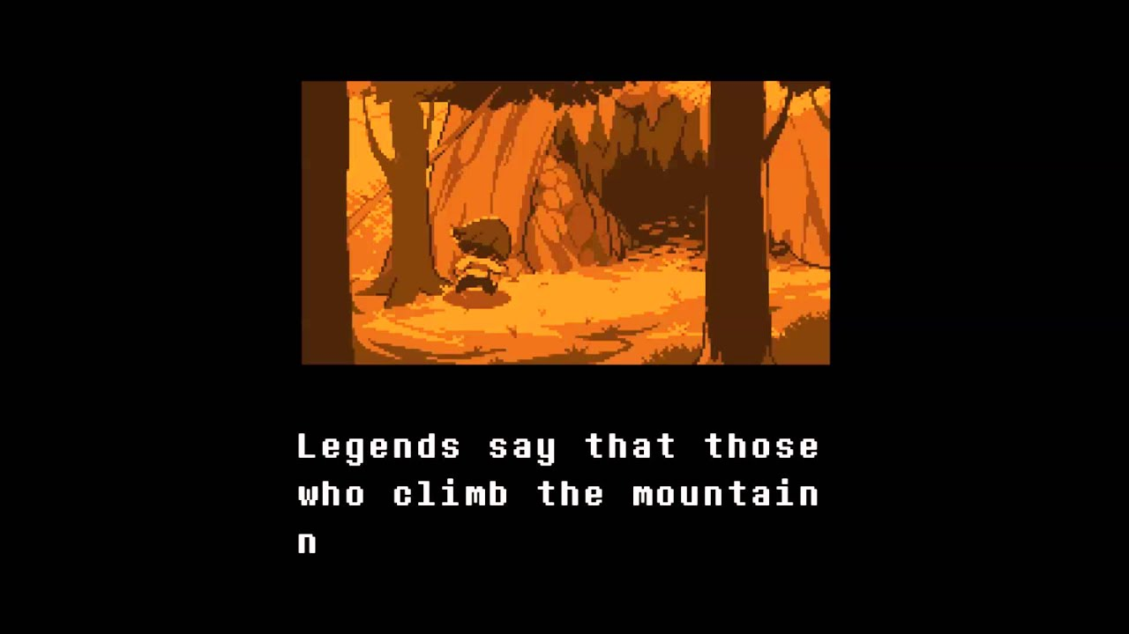

The image above is what the intro to the game should kinda look like. Black background, white pixel text, below you can put in the corner “tap to skip”

Slide 1

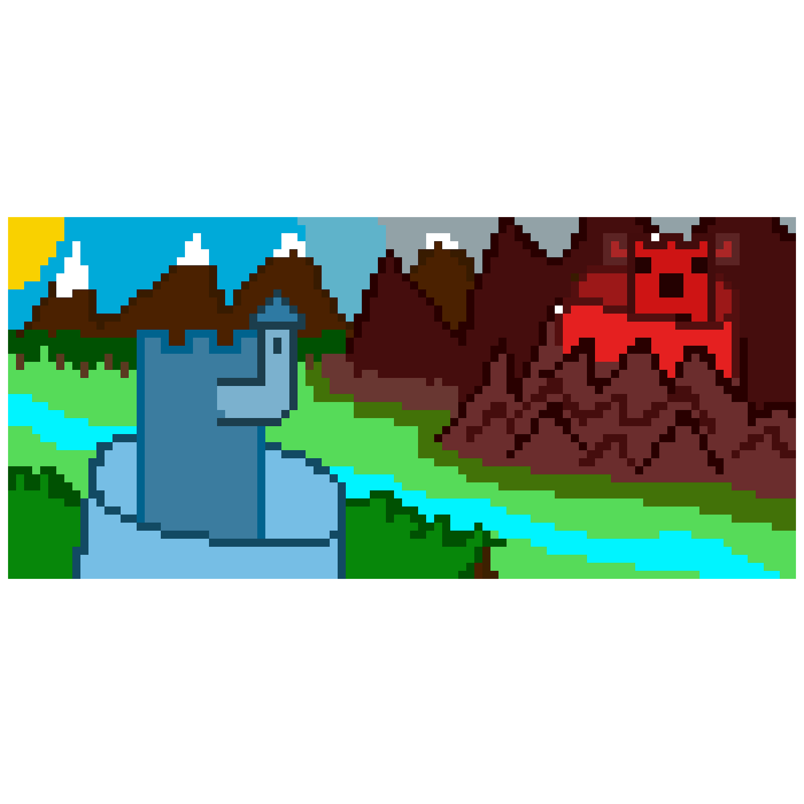

Long ago there was the Blu and Rhed kingdoms. Both were rival kingdoms. The Blu kingdom stood for peace and kindness while the Rhed kingdom thrived on chaos and anger.

Slide 2

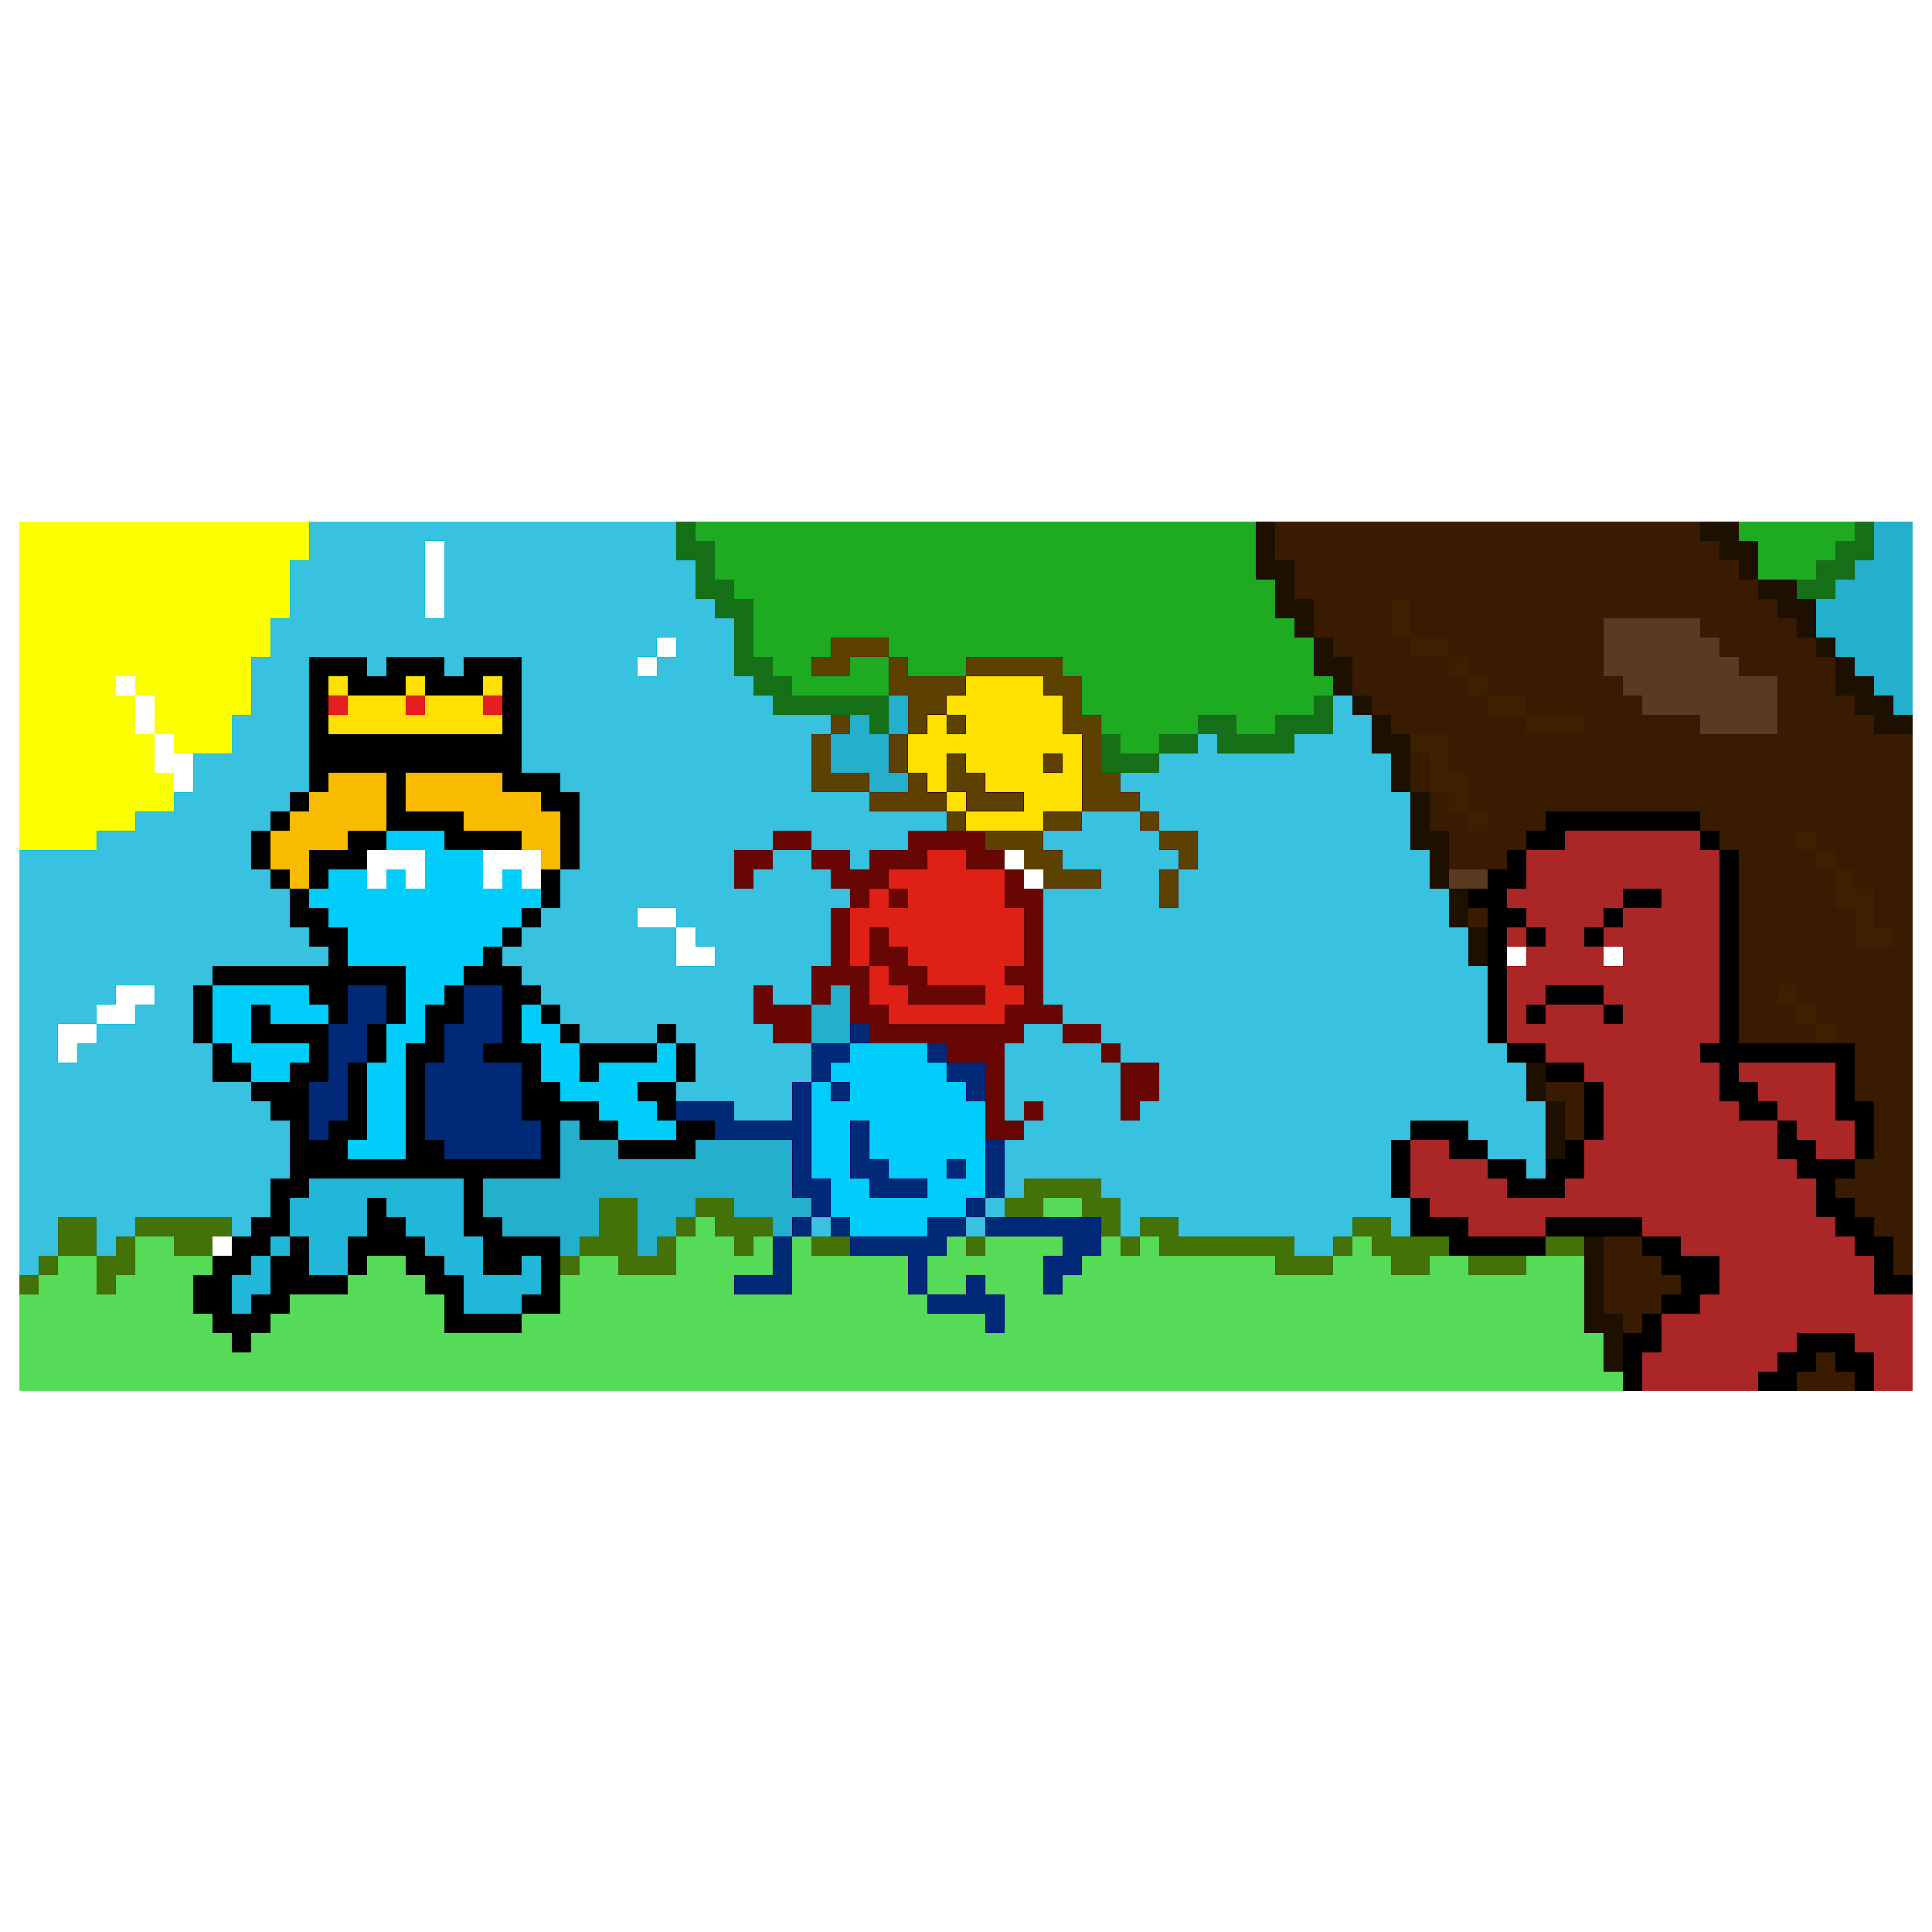

The Rhed kingdom hated the Blu kingdom’s king, Blue. They hated how well he got along with others and hoped to kidnap him and bring chaos to the land.

Slide 3

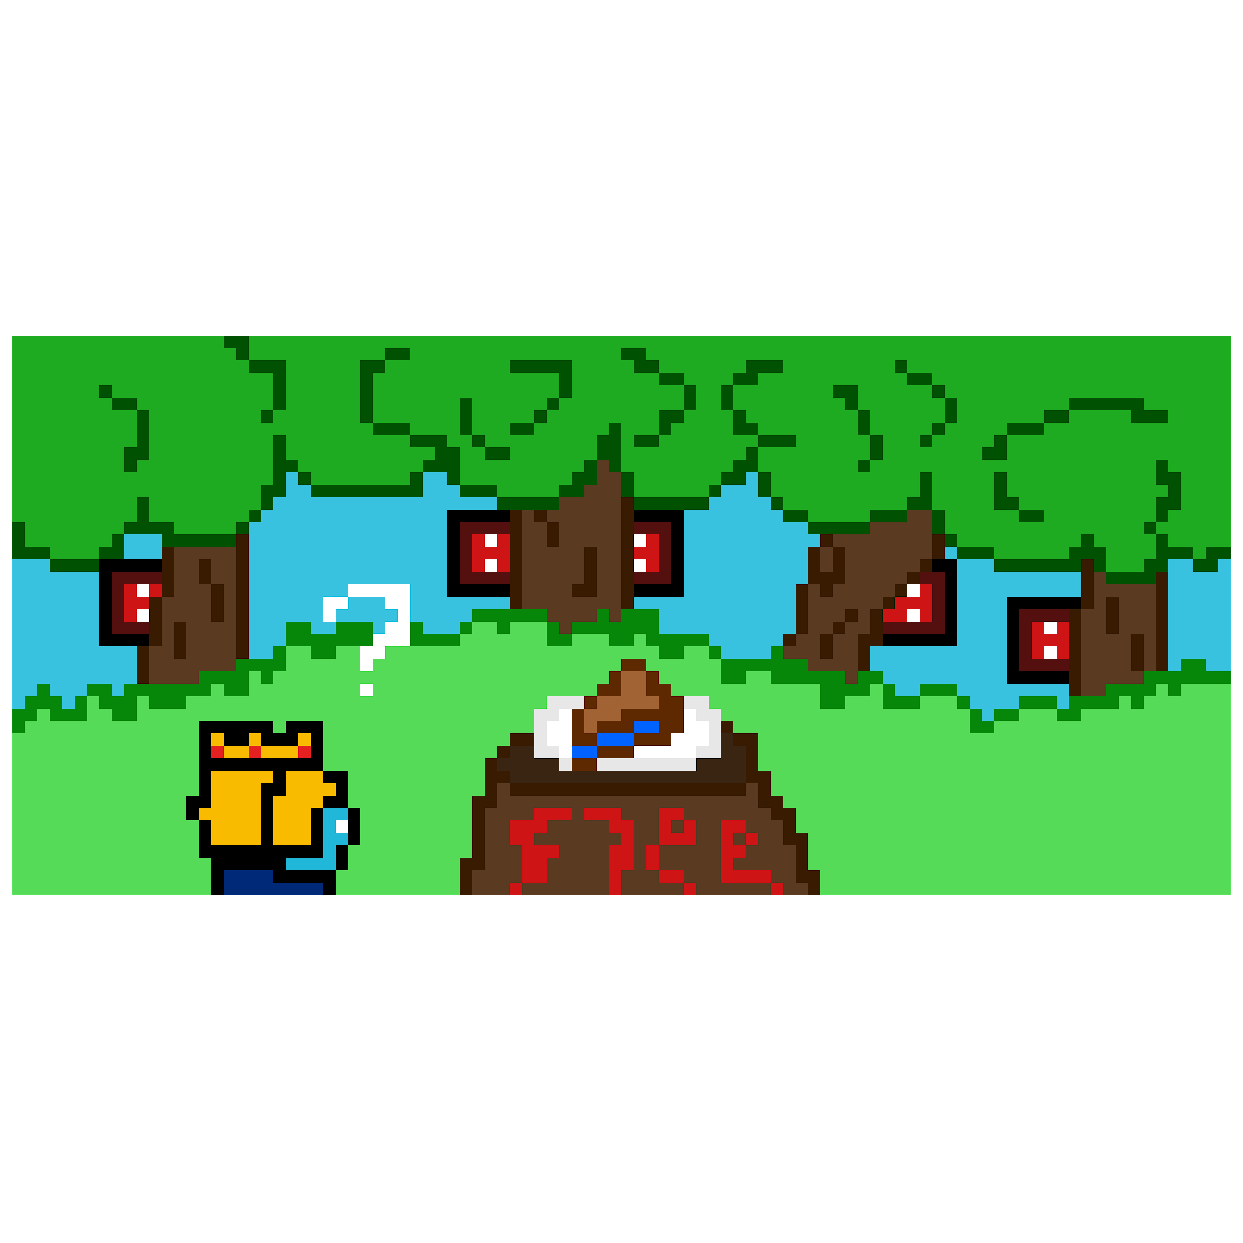

So, The Rhed kingdom decided to lure Blue into a trap using his favorite food, blueberry pie.

Slide 4

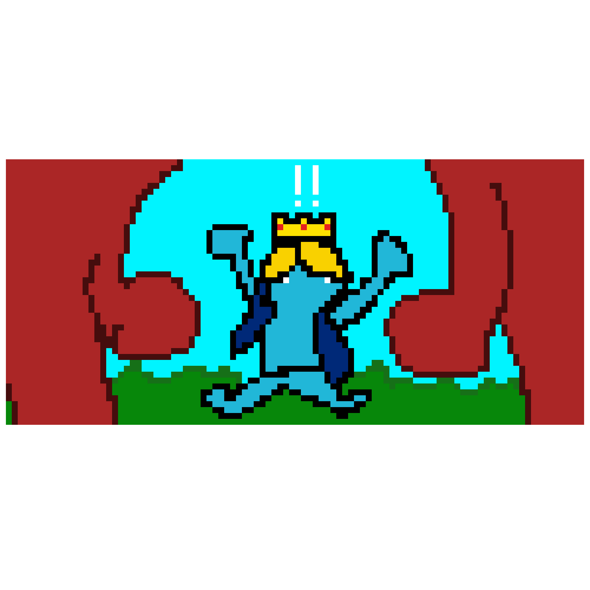

After being ambushed it’s up to you, to protect the king and tap all the Rhed kingdom goons out of existence!